Дополнительные материалы к теме «Школа»
(6 класс)
Коммуникативная задача:
- Сравнить распорядок работы школы в Республике Беларусь и в стране изучаемого языка
Материалы подготовлены учителем английского языка квалификационной категории «учитель-методист» государственного учреждения образования «Средняя школа №6 г. Жодино» Коледа С.М.

School Day in England
- Look through the text. Could you guess the meaning of the underlined words? What are your guesses?
- Who can you see in the picture? What are they doing? Are the children enjoying themselves? Why?
- Read the text to learn more about English schools. Do you have the same school rules?

School Day in England
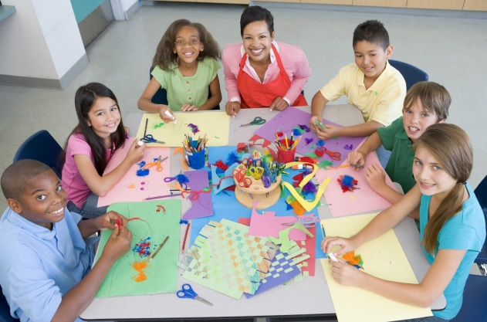Hi. My name’s James. I’m eleven years old and I live in the south of England. Would you like to know what my school day is like? Oh, it’s great. I leave home for school at 8.30. Some of my classmates come to school by bus but I walk to school. It takes me only 5 minutes to get there because I live not very far. Every day on my way to school I meet a lollypop lady who helps me and my schoolmates to cross the road. She’s always very polite.
1
4
3
2
6
5
Have you ever heard that we have school names not numbers as in your country? My school’s name is Cedar Grove School. It starts at 8.50 with class registration and singing songs. The first lesson begins at 9.45. Today it’s Art. We draw different pictures in class. Sometimes we organize exhibitions of our works. I’m good at drawing butterflies. I want to become a naturalist to study nature.
At 10.30 it’s break time. I play games with my friends on the playground. At 10.45 I have the second lesson – ICT. Lunch time is at 11.30. I eat lunch in the canteen with my friends. It may be pasta and salad with apple juice. Many children bring their own packed lunch from home. A packed lunch usually consists of sandwiches, fruit, a drink and a packet of crisps. After lunch we play on the playground. Lesson three starts at 12.15. Today it’s Science. The end of the school day is at 3.15. I can go home with or stay at school and join after school clubs.
This is my timetable.

 | MONDAY | TUESDAY | WEDNESDAY | THURSDAY | FRIDAY
9.45 - 10.30 | Maths | Drama | Music | Art | French
10.45 - 11.30 | English | Maths | Geography | ICT | Music
BREAK
12.15 - 13.30 | Gymnastics | ICT | Maths | Science | Gymnastics
12.30 - 13.30 | Crafts | French | Science | English | ICT
LUNCH
2.30 - 3.15 | Music | Geography | ICT | Maths | History
AFTER SCHOOL CLUBS
 | Tennis | Football | Tennis | Football

- Look at the picture. What lesson do the children have? Where is James? Why do you think so?
- Work in pairs. Give answers to the following questions:
- How long does it take the boy to get to school? Why?
- Do English schools have names or numbers?
- What do the children do during their break?
- What is a packed lunch?
- How many lessons does James have every day?
- What is James interested in? Why?

- Look at the timetable of a pupil from Belarusian School. Work in pairs to compare the boy’s and James’ timetables.

 | MONDAY | TUESDAY | WEDNESDAY | THURSDAY | FRIDAY
8.00 – 8.45 | Maths | PE | History | Maths | Rusian
9.00 – 9.45 | English | Maths | Belarusian | PE | Italian
9.50 – 10.35 | Science | Rusian | Maths | Science | History
11.05 – 11.50 | Belarusian | English | Science | English | ICT
12.00 – 12.45 | Music | Geography | ICT | Art | Biology
12.55 – 13.40 | PE | Art | Biology |  | PE
AFTER SCHOOL CLUBS
16.00 – 17.00 | Art | Basketball | Guitar | Volleyball

- The photos below are examples of some of the lessons the children learn at James’ school. Discuss in pairs what pupils do at these lessons. Use the words from the help box.

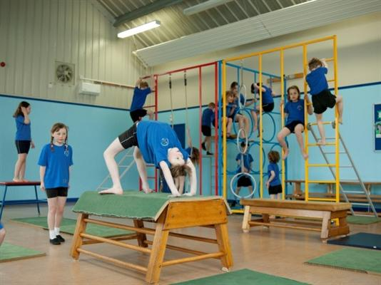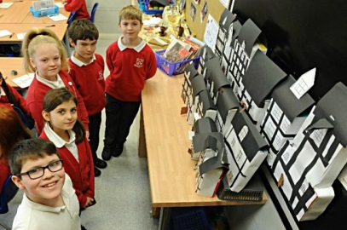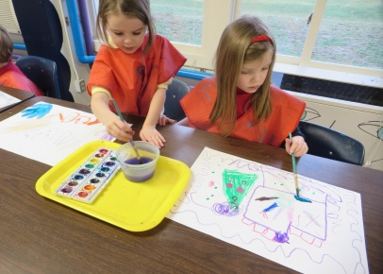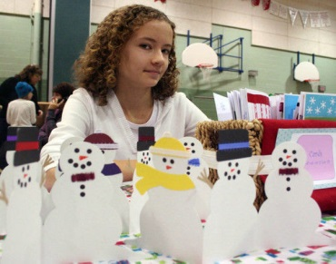
Gymnastics
ICT
Science
History
Art
Crafts

Help box
to see famous paintings / sculptures, to learn more about art, to deepen knowledge, to become strong, to visit museums, to have fun, to experiment, to surf the net, to create, to draw pictures, to learn the laws of nature, to play computer games, to get knowledge about historical events, to read historical books, to train, to perform

